Memory Driven Processor

Author: Brian Korsedal

Iwishihadacompany, Inc.

Table of Contents
Preface 3
Revision History 3
Document Requirements and Objectives 3
Applicable Documents 3
Overview 4
Processor core 4
TC 6
Bus Logic 8
Address Decode and Mux 8
Multiconnect and Buffer 9
Op and Mem 10

Preface

Revision History
Revision | date | Author | Description of Changes
1.0 | 1/04/02 | Brian Korsedal | Draft

Document Requirements and Objectives
This document is intended to describe a new processor that derives its functionality from being asynchronous and processing data by it’s location in memory

Applicable Documents

Overview

Processor core
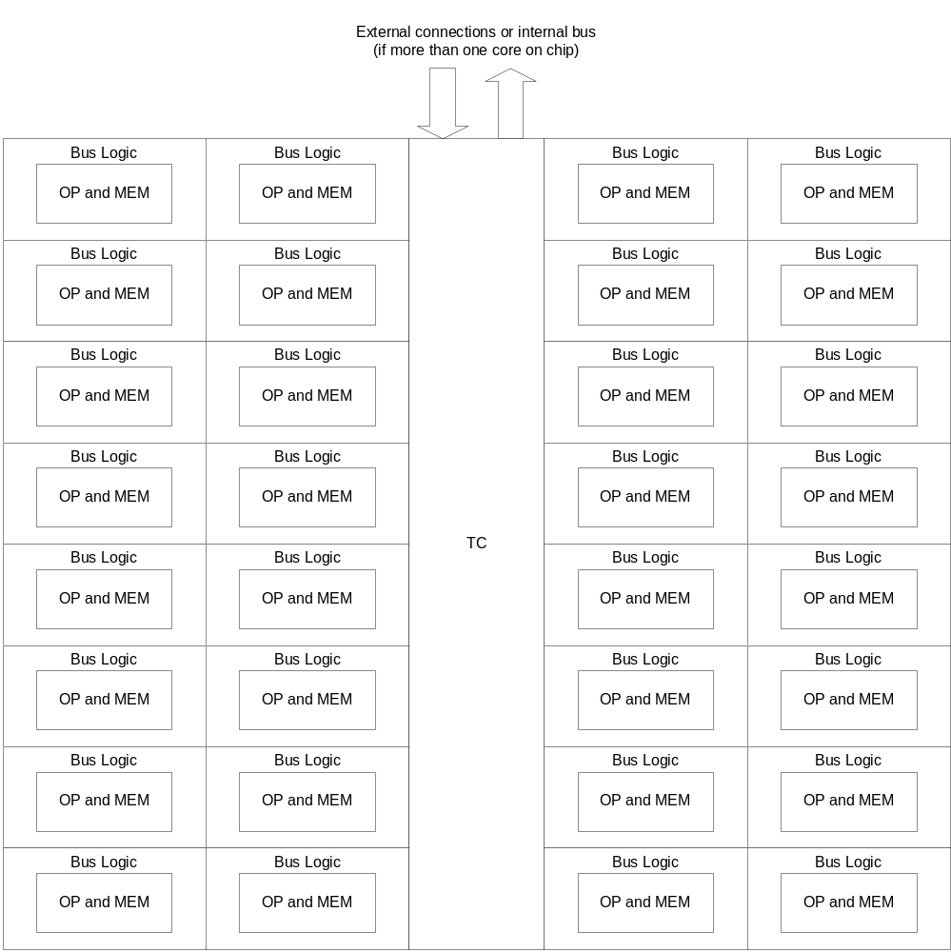
This is a diagram of a single core. There can be multiple cores in a chip. First generation systems should have one core. In future generations, try to keep the changes to the core design minimal (tweeking) and simply increase the number of cores. This will help software optimize code to run on this core. There are three major units of a core.
The TC (Thread Control), Bus Logic and blocks containing Operations and Memory. The TC contains blocks to control threads and an intricate system of pointers. All variables exist in the memory, the TC only deals with pointers. This should create a very efficient architecture. It might be possible to adapt a current risc processor for this function.
Bus Logic blocks manage the transport of data. Because commands are generated by data being in a certain location, the Bus Logic also transports commands (sort of). Each Bus Logic block consists of four external connections (North, South, East, West). Each connection consists of two one way connections, an input and an output. These connections are 64-bits wide (32 data bits and 32 address bits). Each input can transmit to any of the four outputs (each output has a small buffer). Each input can also transmit to the Op and Mem block.
Op and Mem blocks are all different. Some of the standard things is that they contain four sets of memory. A and B blocks of memory contain data pairs that are waiting to be processed by the Op. The result block of memory contains the results of the operation (this block should be four times bigger than the A or B block of memory and there should be a way to correctly map data, to be figured out later). There is also a destination block of memory. The destination block is the same size as the results block. There is a function which scans through some status registers to determine the next available memory pair (A and B pairs as well as result and destination pairs). A and B pairs go into the OP, result and destination pairs go back to the Bus Logic.

TC
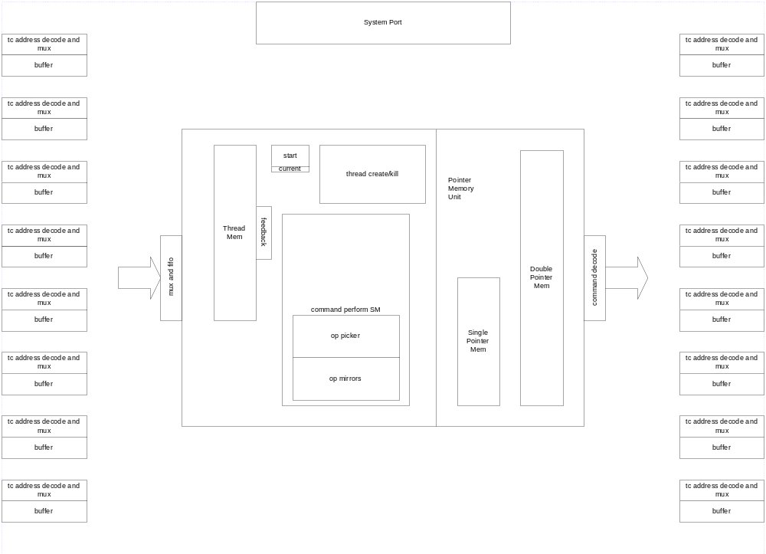
The TC consists of connections to the Bus Logic, Thread Controlling functions, Pointer Memory and a connection to external components. The Thread Controlling block has a memory block that contains thread commands. There is a small buffer containing the start locations of various threads (the end location is the next start minus one). Another buffer contains the current thread position. There is a feedback block, this senses if the current command affects a location in the pointer memory (such as the current thread position for loops).
A very important block handles creating and destroying threads. When a thread is created, it takes machine code and maps all the variables to currently available pointers. It will work off a set of commands that should be stored in the file (the compiler will make most of the commands to this block).
Another important block issues the commands. It does this by writing a specific address to the proper pointer location. When a pointer location has an address written too it, it creates an address/data pair that will send the variable to the new location (which will perform the new command) and then accepts the new value for the current location of the variable. Operations can be performed on a variable while it is in transit. In fact a whole chain of commands can be sent out into the Bus logic. These commands will organize themselves to the proper locations and create a path that the data will follow. These commands do not need to arrive in the proper order as long as they are issued properly.
The Pointer Memory Unit consists of single pointer memory and double pointer memory. When a branch is reached in a program (an if then statement or such), instead of waiting for the results, two copies of the variable are processed. Later, which ever variable is wrong will be destroyed. This is done by sending the data to an Op and Mem block designed to copy the data to two locations. Each new variable is mapped to a pointer in the double pointer memory. The address in the single pointer memory now will point to a location in the double pointer memory. Any command that would be performed on that variable is now performed on the two variable in the double pointer memory. An address in the double pointer memory can point to another address in the double pointer memory. This will allow deep processing of branches in parallel. There should be a mechanism to limit the number of times we can branch. It might be good to split up the double pointer memory into three units. One unit is pointed to by the single pointer memory. Another can be pointed to by the first double pointer memory (this would contain second branching). The third would be pointed too by the second double pointer memory (this would be the third branching variables. It would make sense to have different sizes for each block. Like a 4 to 2 to 1 ratio.

Bus Logic
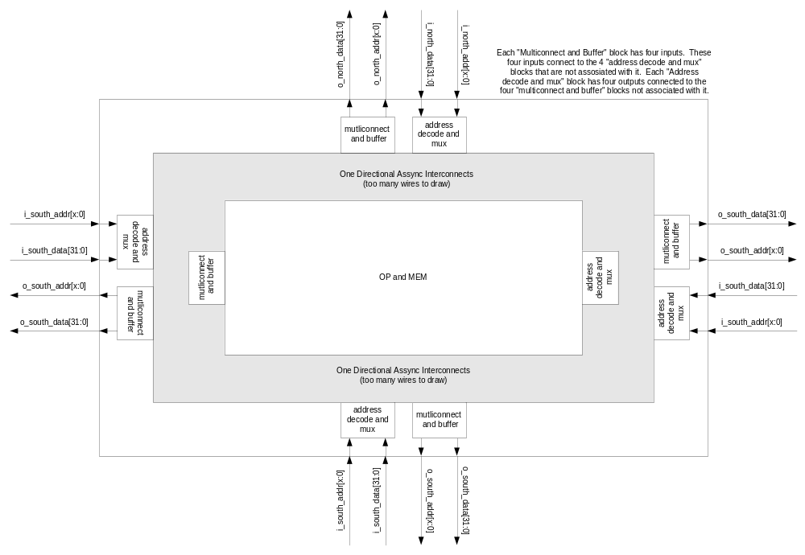This is the Bus Logic. Some of the parts are better described in the following diagrams.

Address Decode and Mux
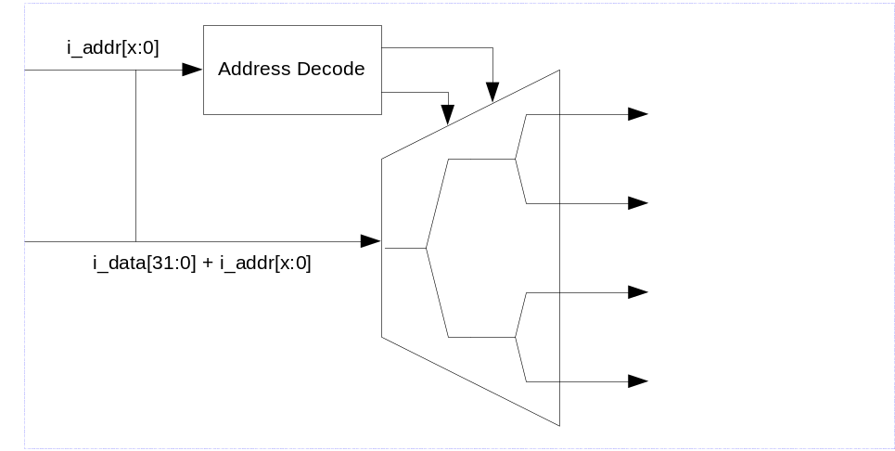

Multiconnect and Buffer
(this one needs some work)
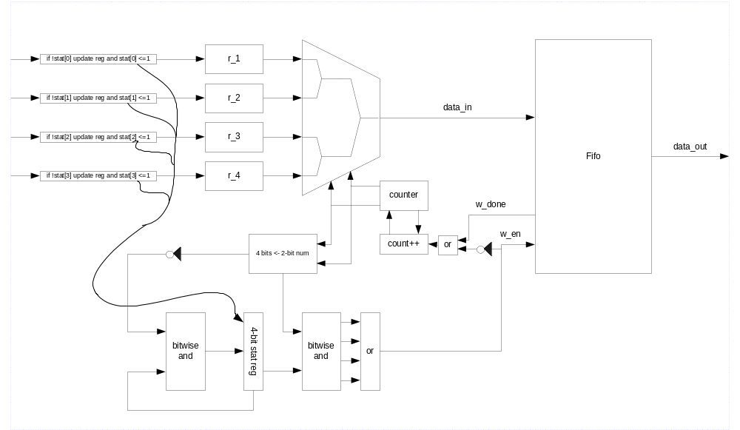

Op and Mem
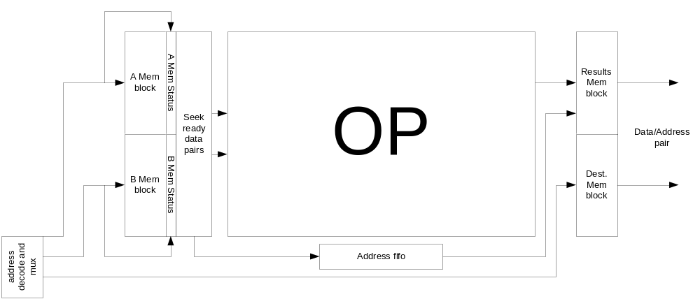

This needs some work, but I’m going out to lunch now, maybe I’ll finish things up later.

